The European Permaculture Convergence 9
June 18th-23rd 2008
Permaculture Council for Europe
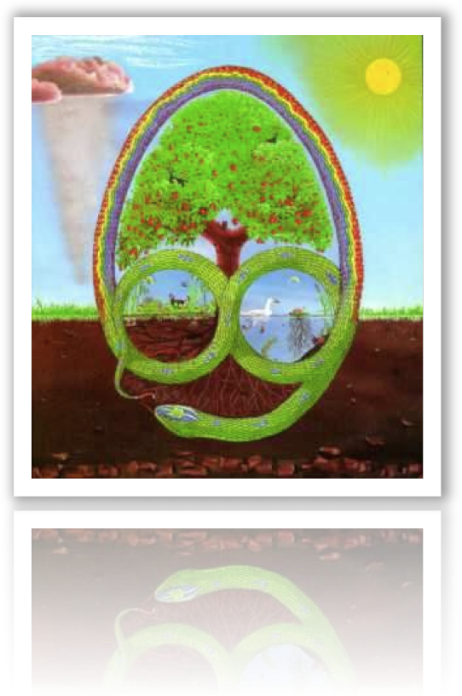
Permaculture Council for Europe
Report from the 9th European Permaculture Convergence

Page No. Contents Process

3 Introduction Observation
History of the European Convergence
4 Participants list
5 Programme of events Design
7 Excursions
8 Notes from sessions Implementation
11 Council Elections Maintenance
12 EuPC 9Evaluation Evaluation

Introduction

This report aims to communicate the activities of the European Permaculture Convergence, held at the Hostetin centre, Czech Republic, June 18th-23rd 2008.

This report is compiled by The Permaculture Council for Europe (PCE) who are elected at these convergences. At this the 9th European Permaculture Convergence (EuPC9) the following council members were re-elected :

Hannah Thorogood Britain
Pavla Sedlácková Czech Republic & Slovakia
Margeret Holzer Austria and the Alpine region

History of the European Convergence

Pre 2006
The European Institute was originally based in Steyerberg, Germany and managed by Declan Kennedy. In 1996 it moved to Copenhagen, Denmark, to the office of Tony Andersen. In 2006 the Institute was converted into The Permaculture Council for Europe.

The European Permaculture Convergences and conferences have been thus:

Year Location Title
1992 Germany EuPC 1
1994 England EuPC 2
1996 Germany, Prinzhöfte EuPC 3
1998 Slovenia EuPC 4
2000 Czech Republic EuPC 5
2002 Slovakia EuPC 6
2004 Czech Republic EuPC 7
2006 Czech Republic, Brno EuPC 8
2008 Czech Republic , Hostetin EuPC 9

Future
There are suggestions of having the 2010 European Permaculture Convergence 10 in either Britain or France. The council will investigate and communicate.

Participants list

It was agreed by all participants to give out the names and country of each participant. Further contact details for each participant may be available on request from the council or from the representative national permaculture body for each country.

Country Name
Austria Margarethe Holzer
Austria Dr Marlies Ortner
Austria Joseph Ortner
Belgium Pascal Beckers
Britain Andy Goldring
Britain Gabriel Goldring
Britain Angus Soutar
Britain Krysia Soutar
Britain Hannah Thorogood
Czech Republic Helena Vlasinova
Czech Republic Pavla Sedlackova
Denmark Tony Andersen
Germany Karsten Winnemuth
Germany Petra Krubeck
Netherlands Marleen Kaptein
Netherlands Daniël Bos
Netherlands Elisabeth Bos
Netherlands Martha Bos
Slovakia Patricia Cernakova
Slovakia Viliam Popadic
Slovakia Marianna Holusova
Slovakia Čestmir Ruzickova

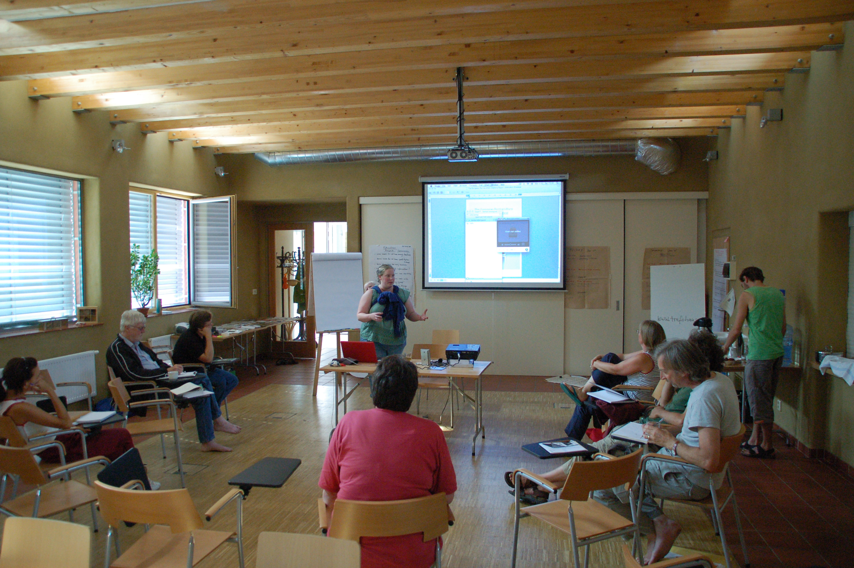
Programme of Events

Tuesday 17th June
Arrival of the Permaculture Council for Europe members.

Wednesday 18th June
Morning Meeting of the Permacultue Council for Europe
Afternoon Arrival of convergence organisers and venue preparation
16.30-18.30 Participants arrival
18.30-19.45 Dinner
20.00 EUPC opening and the programme preparation/agreement

Thursday 19th June
07.30-08.45 Breakfast
09.00-09.30 Opening circle
09.45-12.30 Participants Introduction
The European PC Council report – Hannah Thorogood
Introduction of the working groups, e.g.
        - The diploma process in Europe
        - PC Teachers´ meeting
        - Gruntvig funding bid
        - Permaculture Council for Europe Future
Programme planning
12.45-14.15 Lunch
14.30-17.30 Hostetin excursion
- Exploring the site of the convergence, the apple press and sustainable village
17.45-19.00 First meeting of the working groups / Open Topics / Practical Options
19.00-20:00 Dinner
20:00-22:00 Country Reports

Friday 20th June
07.30-08.45 Breakfast
09.00-09.30 Opening circle
09.30-10.00 Programme of the day / short report of the working groups
Short Reports Working Groups
09.30-12.30 Permaculture Economy – Pavla Sedlackova
- Self reliant permaculture economy - ´More than profit´ businesses\
- Eco/Permaculture Garden Design – an example of a small business in the Czech Rep. - Lucie Komendová
- Permaculture Livelihoods - Andy Goldring
12.45-14.15 Lunch
14.30-17.30 Pitin Excursion
- A walk to the next village to see a permaculture project
17.45-19.00 International Contacts in Europe – Angus Soutar
19.00-20:00 Dinner
20:00-22:00 The Diploma Process in Europe PCE Report Findings – Hannah Thorogood

Saturday 21st June
07.30-08.45 Breakfast
09.00-09.30 Opening circle
09.30-10.00 Programme of the day / short report of the working groups
10.00-12.30 Transition Towns – Andy Goldring
12.45-14.15 Lunch
14.30-19.00 Presentation of TRA.FO – a project in Kassel, Germany - Karsten Winnemuth
19.00-20:00 Dinner
20:00-22:00 IPC8, Brazil Report – Margrethe Holzer

Sunday 22nd June
07.30-08.45 Breakfast
09.00-09.30 Opening circle
09.30-10.00 Programme of the day / short report of the working groups
10:00-11.00 Key Note: 10.000 Trees - Tony Andersen
11.15-12.30 Council Election
Introduction to IPC9 in Africa – Margrethe Holzer
12.45-14.15 Lunch
14.30-17.30 Nezdenice Excursion
17.45-19:00 European Education Working Group Project - Marlies, Angus, Margrethe
Future of the Permaculture Council for Europe - Discussion
19.00-20:00 Dinner
20:00-22:00 Pictures – IPC8, EUPC8 – Angus Soutar

Monday 23rd June
07.30-08.45 Breakfast
09.00-09.30 Opening circle
09.45-11.15 Urban Permaculture – a case study of Culemborg, NL – Marleen Kaptein
Holistic Management – Andy Goldring
11.30-12.45 Evaluation of the EUPC 8
12.45-14.15 Lunch
14.30-17.30 Bojkovice Excursion
17.45-19.00 Closing Circle
19.30 ∞ Farewell Party and Saint John Eve Celebration with some music

Tuesday 24th June
8.00-9.30 Breakfast
9.30-11.00 The EU Council meeting
Morning Participants Departure

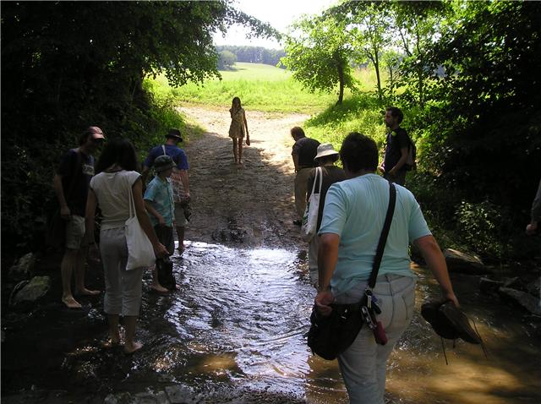
Excursions

Thursday 19th June – Hostetin
The group were shown around the venue and village of Hostetin

Friday 20th June – Pitin
Zdeněk Ševčík is a private fruit grower and agriculturist. He has been a keen organic fruit grower since 1993. He grows trees on the 3,5 ha where he works with nature. No chemicals are used, he mulches with grass under the trees, puts birdhouses in the trees, etc. During winter he feeds the wild birds with sunflower seeds. He makes reptiles houses from stone and wood. All this is done as Integrated Pest Management. He saves some fruit for drying or sells fruit to a nearby factory producing juices. He works on producing organic juices. He won a price for ecological agriculture in 2001.

Sunday 22nd June - Nezdenice

Jolka and Igor Janta. This friendly young couple work on their own private paradise. They built a little house and now they are working on the surroundings. They plan to have a small gardening shop. Currently they are helping Aysha to grow succulents for green roofing, different herbs and perennials.

Monday 23rd June - Bojkovice
Radim “Aysha” Pesek is a gardener, fruit grower, a private ecological agriculturist, a musician and a publisher. The nursery is in the White Carpathians. The work in the nursery is done using traditional processes in balance with nature. Its production is focused to reproduction and sale of old varieties of apple trees and pears; rare fruit varieties; new resistant fruit varieties and rare wild Carpathian trees.

Notes from Sessions

Friday 20th June
Permaculture economy

Presentation by Lucie Komendova, Eco / Permaculture Garden Designer
www.zahradaproradost.cz (Garden of Joy)
Lucie is a landscape architect with an office based in Brno/Czech. Her company is operating in Czech offering ecological design. She presented several projects designed by her in the last three years. Lucie said that aesthetics were important in her work. The discussion that followed made the following points about permaculture business:

Advantages
- Aesthetics - looks good
- Natural patterns are used very effectively

Disadvantages
- Not enough contractors (gardeners) understand the principles

Interesting points
Some Permaculture projects are seen as unattractive and messy, giving a poor image to permaculture.

Presentation by Andy Goldring ‘Permaculture livelihoods’
www.permaculture.org.uk (Permaculture Association of Britain)
Andy gave an overview on successful companies working with permaculture ethics. Guilds- Support Groups and Teams. The Middle - small firms combine to do bigger jobs. Social Enterprise. Our discussions raised the following points about the success of our enterprises

Advantages
(Kingston, UK) Bioregional Development Group - set up a supply network when they could not supply just one store in a National chain
Polycultures
Personal Choice
One thing leads to another
Creative use of existing skill

Disadvantages
EU rules – restrictions
Must understand commerce
Encourages dilletante + amateur behaviour
Does not always work
Financial backing required

Interesting points
People change jobs – focus?
Marketing
Care with promoting permaculture
Reputation – it works both ways

Friday 20th June
International Contacts in Europe
1. Current Situation:
There is an urgent need to exchange information between the countries about associations, groups, individuals, projects and education possibilities.
2. Aim:
- Clear Information between associations, groups, individuals in the European countries about education possibilities, projects, meetings, convergences, etc.
- “Harmonised” and compatible education standards (PDC’s, PC-Diploma).
- Flexibility for the students to move into a different system and still obtain a recognised PDC certificate, PC-Diploma.
- Opportunities to access suitable projects as an apprentice.
3. Action plan:
- Building of a Project group who can start and support the process
- Situation analysis
Needs analysis
Detail planning = DESIGNING the Project
- Provide information for associations, groups and individuals about the results of the analysis and the planning proposal.
- Invite associations, groups and individuals to nominate and to send delegates to this “European Working Group for Permaculture Education”.
- Organisation and running of the first delegates meeting:
- Topics are: Agree aims and set objectives
    - Planning of the work to be done
      - Organisation of the group
      - Organisation of the work
      - Planning further meeting(s)
      - (Support the planning of the EUPC 10)
      - (Create strategies how to attract people to PC and PDC)
- The delegates will discuss the agenda and report back to their organisations.
- The consensus-building process continues until clear agreements are achieved between the associations, groups and individuals who have sent delegates.
- The project group will continue to support the group of delegates and individuals.
- At the end of the process there will be a valuation of the project group.
4. Project Group:
In alphabetical order: Margreth Holzer, Marlies Ortner, Angus Soutar,
Helpers, Contacts: Patricia Cernakova – analysis work
Andy Goldring – database availability, Grundtvig processing, teachers survey (available here), software (“Survey monkeys”)
Pavla Sedlackova – contacts
5. Time scale: 2008-2010
6. Costing:
7. Finance:
Education Project – comments:
  - Some areas do not have enough teachers.
  - Some areas do not have (good) diploma tutors
  - Some areas have too many teachers
  - We do not have enough information
  - What can we do in our own countries?
  - “Education project” can work with council as a “working group”.
  - Education Project Working Group” is based on education and will look for delegates from organisations.
  - The associations should answer the questions of the “needs analysis”
Saturday 21st June
Transition Towns (http://transitiontowns.org)
Presentation by Andy Goldring
The mission is to inspire, to encourage, to network, to support and to train communities as they as they consider, adopt, adapt and implement the transition model in order to establish a Transition Initiative in their locale. The transition model emboldens communities to look peak oil and climate change squarely in the eye and unleash the collective genius of their own people to find the answers to this big question: for all those aspects of life that this community needs in order to sustain itself and thrive, how are we going to:
- Significantly rebuild resilience (in response to peak oil)
- Drastically reduce carbon emissions (in response to climate change)?

Monday 23rd June
Urban Permaculture – a case study of Culemborg, NL
Presentation by Marleen Kaptein
The ecological district EVA-Lanxmeer, pilot for sustainable urban development in Culemborg
EVA-Lanxmeer is an ecological district in the city of Culemborg, a small town of 26.000 inhabitants in the centre of the Netherlands, surrounded by a beautiful river landscape. The aim in the EVA project was to achieve and demonstrate sustainability in all its aspects, not only materially, but also in social, cultural, landscape and economical aspects. EVA-Lanxmeer has been established in a co-production between the EVA Foundation and the city of Culemborg and with active participation of future inhabitants.

The concept for the EVA project is based on the combined philosophy’s of ecological building, organic architecture and landscape architecture and Permaculture design principles.
In 1994 she founded the EVA Foundation (in Dutch: Stichting E.V.A.- Ecologisch Centrum voor Educatie, Voorlichting en Advies).

The aim of the EVA Foundation is to make a contribution to a growing awareness of the vulnerability of the environment in which we live. And to demonstrate to a large public that we can design and build sustainable urban districts of a high quality: good for Planet, People and Profit. The partnership with the municipality of Culemborg started in 1996.

The plan for the EVA project offers conditions for living, working and recreation in a natural environment. It consists of:
- Ecological design of the urban plan, based on the ‘Genius Loci’
- 250 houses and apartments, ateliers and studios
- ecological office buildings
- a biological city farm for local food production, education and social functions
- the EVA Centre for integral ecology (in planning phase)
- integrated water resources management: reducing of hard surface, rainwater storage and biological water purification integrated in the landscape
- energy concept aimed at CO2 neutral: use of passive solar energy, good insulation, low temperature heating systems, and use of renewable energy resources
- small streets and decentralised parking lots: reduce use of cars

Marleen Kaptein
In 1993 Marleen Kaptein took the initiative for the project EVA-Lanxmeer. In the previous years she had worked at the Technical University of Delft, in a research group Open Building Development Model, and was member of the board of the VIBA and the International Forum Man and Architecture. In 1992 she followed the Permaculture Design Course with prof. Declan Kennedy.

Council Elections

As decided at the European Permaculture Convergence 8, in Brno, Cazech republic 2006. The participants of the European Permaculture Convergence have the authority to elect the individual members of the Permaculture Council for Europe for the next 2year term. To run from one European Permaculture Convergence to the next.

At the European Permaculture Convergence 9, held at Hostetin, Czech republic 2008. The Permaculture Council for Europe Election results were as below.

Members of the previous term of council to stand down:
Andy Langford Global, originally Britain
George Sorbol Britain & Eastern Europe
Sonja Horstner Germany
Tony Andersen Scandinavia

Members of the previous term of council for stand again for election:
Hannah Thorogood Britain
Pavla Sedlácková Czech Republic & Slovakia
Margeret Holzer Austria and the Alpine region

There were no other candidates standing for election.

The three who stood for election (Hannah, Pavla and Margeret) were unanimously voted to be the Permaculture Council For Europe 2008-2010.

The main duties of the council are:
EuPC10: to ensure the European Permaculture Convergence 10 happens in 2010. They will decide where is happens and who it is hosted by and will support the organisers of the convergence

Funding: to attempt to gain funding for the Permaculture Council for Europe.

More Members: to co-opt more members to the council if they see fit.

Website: to attempt to have some internet representation of the Council.

EuPC9 Evaluation
What went well:
- Programme: flexibility, punctuality, diversity, well managed, interesting, new knowledge
- People: the group energy, to meet each other, interpretation, Gabriel, baby tolerance, companionship, diversity, pre-organisation, nurse Patricia, Hannah & Daniel, everyone
- Food: organised, good quality, responsive, cook & co-cook,
- Council: I.T., computers, projector, passed, elected
- Local economy
- Visits: interesting, regional fruit trees, White-Carpathian region; people interested,
- Facilitation – opening circles
- Welcomed
- Place: camping, rooms
- Local transport
- Music festival
- Outcomes: Diploma process; “Council” resolution; Future of EUPC; New active members in associations; EU Project

What didn’t go so well:
- People: too few, more participation from eastern countries desired,
- Facilitation: 1st day chaotic
- Checklist: pharmacy needed in advance
- Place: acoustics + temperature control difficult; chairs uncomfortable
- More, shorter breaks
- Pre-event: do not count on others to do things (didn’t get done)
- Organisation: fell on too few people, run on debt due to too few people
- First day shorter, programme organisation too long at beginning – start with walk in nature, the forest
- Illness & low energy
- Visits: intro before go to each, time needed to discuss as a group
- Programme: council business before, iron fist of punctuality

Suggestions for next time:
- Website: photos, speaker, portfolio, registration (password, pre-convergence website)
- 1st day shorter
- Identify/acknowledge different needs & interests of attendees – organising, PC interest
- Plan to make a profit
- Music/cultural activities incorporated & advertised
- Games, sport, walk, fun in programme
- Combine with a national convergence
- Practical workshops
- Plant a tree wherever we go
- Help people get over perceptual barrier of distance to event
- Somewhere easier to get to?
- Pre-course – advanced topic, 3 days?
- Computer to borrow/book for participants
- Programme: months in advance (at least some of it)
- More participants
- Survey soon – best time of year, etc.
- Address all minus points
- Day before – programme organising involve those that want to be involved – way to enlarge council (gain interest)
- Q: Does it have to be every other year? – make more use of events already happening
- Contact with the European Associations (they could send people to the convergences)

